GPU Technologies: Current Applications and Their Role in Shaping Future Computing Paradigms

Shivam Patel
Seidenberg School of Computer Science and Information Systems, Pace University
CS 610 – Intro to Parallel Computing
Dr. Jibananda Biswas
May 1, 2025

Contents
1. Purpose 4
2. Introduction 4
2.1 Understanding GPUs: Definition and significance 4
2.2 History of GPUs: Pixels to parallelism 4
3. Technical overview of GPUs 6
3.1 GPU Architecture fundamentals 6
3.2 Parallel Computing: The key to GPU performance acceleration 7
3.3 GPU VS CPU 9
3.4 The role of AI specific chips 9
4. How GPU process data’s 10
4.1 The parallel processing model 10
4.1.1 Single Instruction, Multiple data 10
4.1.2 Massively parallel architecture 11
4.1.3 Threads & wrap scheduling 11
4.2 Data flow in the GPU pipeline 12
4.2.1 Data transfer 13
4.2.2 Instruction Dispatch 14
4.2.3 Execution by cores 14
4.2.4 Memory access and caching 15
4.2.5 Output 16
4.3 GPU Optimization Technique 17
4.3.1 Memory Coalescing 17
4.3.2 Instruction level parallelism 17
4.3.3 Latency hiding 18
4.4 Real world example 18
5. Emerging application of GPUs 20
5.1 GPUs in AI and ML 20
5.2 Scientific computing 20
5.3 Gaming and real time graphics 21
5.4 Blockchain and cryptocurrency 21
6. Future threads 22
6.1 Automatic vehicles and robotics 22
6.2 Edge computation and cloud GPUs 22
6.3 Quantum and Optical computing 23
7. Challenges and sustainability 24
7.1 Energy consumption concerns 24
7.2 Sustainability of large-scale GPUs 24
7.3 Green computing initiatives 25
8. Deepseek v/s NVIDIA 25
9. Conclusion 26
9.1 Summary of key findings 26
9.2 Future impacts of GPU 27
10. References 28

Purpose
The purpose of this paper, is to explore the evolution, complex architecture, and future advancements of GPUs. It aims to provide a comprehensive analysis of how GPUs work and their large expansion in industries like Artificial Intelligence, Gaming and blockchain. This paper also goes through emerging trends in GPU technology, highlighting potential challenges and sustainability. Furthermore, it offers comparison between deepseek vs NVIDIA, explaining how new competition is reshaping GPU market. To conclude, this paper seeks to explain technological advancements, offering insights into their future role in computing & evolution.

Introduction

2.1 Understanding GPUs: Definition and significance
GPU stands for Graphics Processing Unit. A GPU is a specialized electronic circuit initially designed for digital image processing and to accelerate 2D or 3D computer graphics. GPUs were presented in the form of either a video card or embedded in devices like motherboards, mobile devices, personal computers, or gaming consoles (Akenine-Möller et al., 2018). After their initial design, GPUs were found to be useful for performing non-graphical calculations involving parallel problems due to their parallel structure (Nickolls et al., 2008; Owens et al., 2008). The GPU’s ability to perform a vast number of rapid calculations has led to its adoption in diverse fields, including Artificial Intelligence, where they excel at handling data and computationally demanding tasks (Goodfellow et al., 2016; NVIDIA Developer Blog). Other non-graphical uses include neural networks and cryptocurrency mining (Narayanan et al., 2016; Gencer et al., 2018). Nowadays, GPUs are often designed to dedicate their work purely to such specialized fields (Hwu, 2016).

History of GPUs: Pixels to parallelism
Early when GPUs were initially designed, they were created to accelerate graphics rendering for 2D and 3D graphics. Soon after, companies started using GPUs in arcade games and personal home computers.
- 1970s–1980s
  - The first specialized graphics chips appeared in arcade machines. In 1979, Texas Instruments introduced one of the earliest graphics chips, the TMS9918, used in consoles like the ColecoVision (Akenine-Möller et al., 2018). In 1987, IBM introduced the VGA standard, enabling 256-color displays, which became the norm for PC graphics and paved the way for dedicated GPUs (Akenine-Möller et al., 2018).
- 1990s
  - In 1993, NVIDIA was founded and launched its first GPU, the NV1, in 1995. Although not a commercial success, it introduced the concept of hardware-accelerated 3D graphics (NVIDIA Developer Blog). In 1999, NVIDIA released the GeForce 256, branding it as the world’s first GPU with real-time 3D rendering capabilities (Nickolls & Dally, 2010).
- 2000s
  - The GeForce 3 introduced programmable pixel and vertex shaders, allowing more realistic graphics rendering (Akenine-Möller et al., 2018). In 2006, NVIDIA launched CUDA (Compute Unified Device Architecture), enabling GPUs to perform tasks beyond traditional graphics (Nickolls et al., 2008). Around the same time, AMD introduced Stream Technology, a CUDA competitor for general-purpose GPU computing (Hwu, 2016).
- 2010s
  - The AlexNet model used NVIDIA GPUs to train deep neural networks, a major milestone in AI research (Goodfellow et al., 2016). In 2016, NVIDIA launched the Pascal architecture with tensor cores, optimized for deep learning, and the Tesla P100, which became widely used in AI data centres (Jouppi et al., 2017). In 2017, NVIDIA launched the Volta architecture, featuring FP16 precision, boosting AI performance (NVIDIA Corporation, 2022).
- 2020s
  - The A100 GPU, based on Ampere architecture, offered significant improvements in AI performance and mixed-precision computation (NVIDIA Corporation, 2022). NVIDIA’s H100 GPU, based on the Hopper architecture, introduced Transformer Engine acceleration, optimized for Large Language Models (NVIDIA Hopper Architecture Whitepaper, 2022). In 2023, DeepSeek, a new competitor, entered the market with cost-efficient, AI-optimized GPU technology aimed at large-scale AI workloads, putting pressure on NVIDIA’s market position (DeepSeek Technology, 2024; Financial Times, 2024).
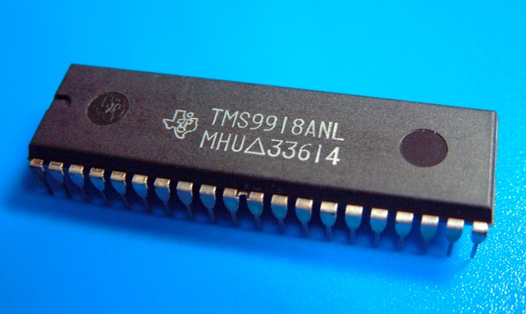  Reference: https://en.wikipedia.org/wiki/TMS9918 | 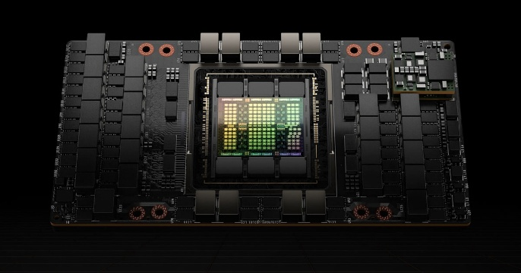  Reference: https://www.nvidia.com/en-us/data-center/h100/

3. Technical overview of GPUs

3.1 GPU Architecture fundamentals
The GPU architecture is designed for massively parallel processing, making it ideal for graphics rendering, AI, and high-performance computing (HPC) (Nickolls & Dally, 2010; Owens et al., 2008). Unlike CPUs, which handle sequential tasks, GPUs consist of Streaming Multiprocessors (SMs) or Compute Units (CUs), used in NVIDIA and AMD architectures respectively (Hwu, 2016). Each contains hundreds of cores capable of executing thousands of threads concurrently. The architecture includes a multi-level memory hierarchy, with global memory (VRAM) for large data storage, shared memory for thread-level data exchange, and L1 or L2 caches to reduce memory latency (NVIDIA Corporation, CUDA Programming Guide; Hwu, 2016).
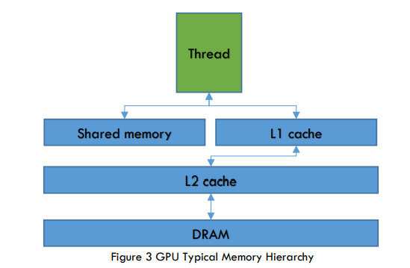
Reference: Wyrwas, R. (2018). Graphics Processing Units: Trends and Evaluation for Space Applications. NASA NEPP.
https://nepp.nasa.gov/files/29564/NEPP-BOK-2018-Wyrwas-GPU-TN60884.pdf

Modern GPUs also feature specialized cores, such as Tensor Cores (NVIDIA) and Matrix Cores (AMD), optimized for AI and machine learning tasks (NVIDIA Corporation, 2022; Hwu, 2016). The Single Instruction, Multiple Data (SIMD) execution model allows GPUs to apply a single instruction across multiple data points, boosting parallel efficiency (Nickolls et al., 2008; Khronos Group). Programming models like CUDA and OpenCL enable developers to harness GPU power for scientific simulations, deep learning, and real-time graphics (Nickolls et al., 2008; Khronos Group; Hwu, 2011). With advancements in ray tracing and AI accelerations, GPUs are transforming industries such as gaming, AI research, and blockchain (Akenine-Möller et al., 2018; Goodfellow et al., 2016; Gencer et al., 2018).

3.2 Parallel Computing: The key to GPU performance acceleration
Parallel computing is the foundation of modern GPU performance, enabling them to handle large-scale, data-intensive tasks with exceptional efficiency (Hwu, 2016; Owens et al., 2008). Parallel computing in GPUs works by executing thousands of operations simultaneously using a massively parallel architecture and the SIMT (Single Instruction, Multiple Threads) execution model (Nickolls et al., 2008; NVIDIA Corporation, CUDA Programming Guide). Unlike CPUs, which process tasks sequentially, GPUs divide complex computations into smaller, independent tasks and process them concurrently across hundreds or thousands of cores (Nickolls & Dally, 2010; Hwu, 2011). In this model, threads are grouped into warps (NVIDIA) or wavefronts (AMD), with each thread executing the same instruction on different data points in a parallel manner (NVIDIA Corporation, 2022). This allows GPUs to efficiently handle complex vectorized operations such as matrix multiplications, image rendering, or AI inference (Goodfellow et al., 2016; Pharr et al., 2016). To optimize performance, GPUs use a multi-level memory hierarchy, including global memory (VRAM) for large data and shared memory for fast inter-thread communications, along with caches to reduce memory access latency (Hwu, 2016; Patterson & Hennessy, 2017). During execution, if threads encounter conditional branches, the GPU temporarily serializes divergent paths, reducing efficiency but ensuring correctness (NVIDIA Corporation, CUDA Programming Guide). This way, GPUs deliver exceptional performance and scalability.
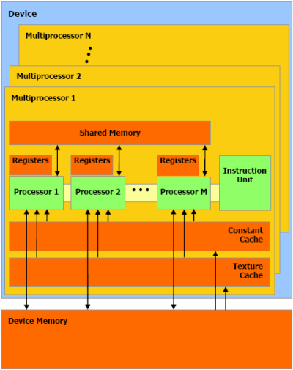
Reference: https://forums.developer.nvidia.com/t/simt-simd/8706

3.3 GPU VS CPU
Features | GPU (Graphics Processing Unit) | CPU (Central Processing Unit)
Architecture | Massively parallel with hundreds to thousands core | Sequential processing with fewer powerful core
Execution Model | SIMT (Single Instruction, Multiple Threads) for parallel tasks | SISD (Single Instruction, Single Data) for sequential tasks
Clock Speed | Lower clock speed (1-2 GHz) but more bandwidth | Higher clock speed (3-5 GHz) with fewer cores
Memory Type | Uses VRAM for higher bandwidth | Uses RAM with lower bandwidth
Cache Memory | Uses L1 and L2 caches shared across multiple cores | L1, L2 and L3 caches with larger cache sizes per core
Programming models | Uses CUDA (NVIDIA), OpenCL, HIP (AMD) | Uses OpenMP, C++, Python or traditional framework
Workload suitability | Best for parallel executional tasks: AI, ML or simulation | Best for serial tasks: OS operation, apps
Use cases | AI, Gaming, rendering etc. | General-purpose computing, multitasking etc.
Cost and Price | More expensive for high-performance GPUs | Generally, more affordable

3.4 The role of AI specific chips
AI-specific chips are specialized hardware designed to optimize the processing and execution of Artificial Intelligence (AI) and Machine Learning (ML) tasks. Unlike traditional CPUs and GPUs, these chips are purpose-built to accelerate specific AI workloads, such as deep learning, neural network training, and inference (Jouppi et al., 2017; Hennessy & Patterson, 2017). Prominent examples of AI-specific chips include Tensor Processing Units (TPUs) developed by Google, which are highly optimized for matrix operations used in neural networks (Jouppi et al., 2017), and AI-specific GPUs like NVIDIA’s A100 and H100, designed to handle massive parallel processing tasks in AI models (NVIDIA Corporation, 2022; NVIDIA Corporation, 2023). Additionally, there are ASICs (Application-Specific Integrated Circuits) and FPGAs (Field-Programmable Gate Arrays), which can be tailored to specific AI applications, offering superior performance and energy efficiency for tasks like speech recognition and computer vision (Lightmatter, 2021; Hennessy & Patterson, 2017). These chips significantly outperform general-purpose processors in tasks such as image classification, natural language processing, and predictive analytics, accelerating the deployment of AI across industries such as healthcare, automotive, and finance (Goodfellow et al., 2016; Arute et al., 2019). As AI workloads continue to grow, the development of AI-specific chips will be essential in meeting the increasing demands for speed, accuracy, and efficiency.

4. How GPU process data’s

4.1 The parallel processing model

4.1.1 Single Instruction, Multiple data
Single Instruction, Multiple Data (SIMD) is a parallel computing model, where a single instruction (operation) is executed through multiple pieces of data simultaneously. In GPUs, a group of cores executes the same operation but at different data points (Owens et al., 2008). For example, if a task requires enhancing the sharpness of an image, a GPU can instruct all the cores to perform operations on individual pixels rather than going through the whole image and doing it pixel by pixel (Nickolls et al., 2008). SIMD greatly enhances the throughput of GPUs by reducing overhead and addressing the issues with separate instructions for each data element. Instead, one instruction can handle multiple data streams, optimizing performance and saving time (Hennessy & Patterson, 2017). Modern GPUs are designed around SIMD architectures, though they are often extended into more flexible models, such as Single Instruction, Multiple Threads (SIMT), especially in NVIDIA’s CUDA, to manage both divergence and complex data flows (Kirk & Hwu, 2016).

4.1.2 Massively parallel architecture
Massive parallel architecture refers to a system where thousands or millions of processing units work in parallel on different parts of a task at the same time. In GPUs, it means that the hardware of the GPU is composed of millions or even billions of smaller, simpler cores that operate together to solve large computational problems more efficiently (Nickolls et al., 2008). Unlike CPUs, which have a smaller number of powerful cores designed to perform sequential tasks, GPUs are designed to perform large amounts of tasks in parallel, with many cores working on different tasks simultaneously on the same data (Hennessy & Patterson, 2017). This allows GPUs to be highly effective at workloads where the same operation must be performed simultaneously across massive datasets, such as image processing, machine learning, or scientific computing (Owens et al., 2008). This massive parallel architecture is the reason GPUs are not only critical in graphics rendering but also in fields like Artificial Intelligence, High-Performance Computing, and Deep Learning (Kirk & Hwu, 2016).

4.1.3 Threads & wrap scheduling
Threads are the smallest unit in GPU programming. In a GPU, thousands or millions of threads are created to perform tasks in parallel. Each thread executes the same program, but usually on a different dataset (Nickolls et al., 2008). Instead of managing each thread individually, GPUs group threads into units called warps. A warp is a group of 32 threads that execute the same instruction at the same time following the SIMT (Single Instruction, Multiple Threads) architecture (Hennessy & Patterson, 2017).
Because GPUs can have multiple threads ready to run, the GPU’s warp scheduler decides which warp to execute next based on thread readiness. If a warp is stalled, the scheduler quickly selects another warp to execute, keeping the GPU cores busy without wasting time. This warp scheduling is key to hiding latency and maintaining high performance in massive parallel workloads (Owens et al., 2008).

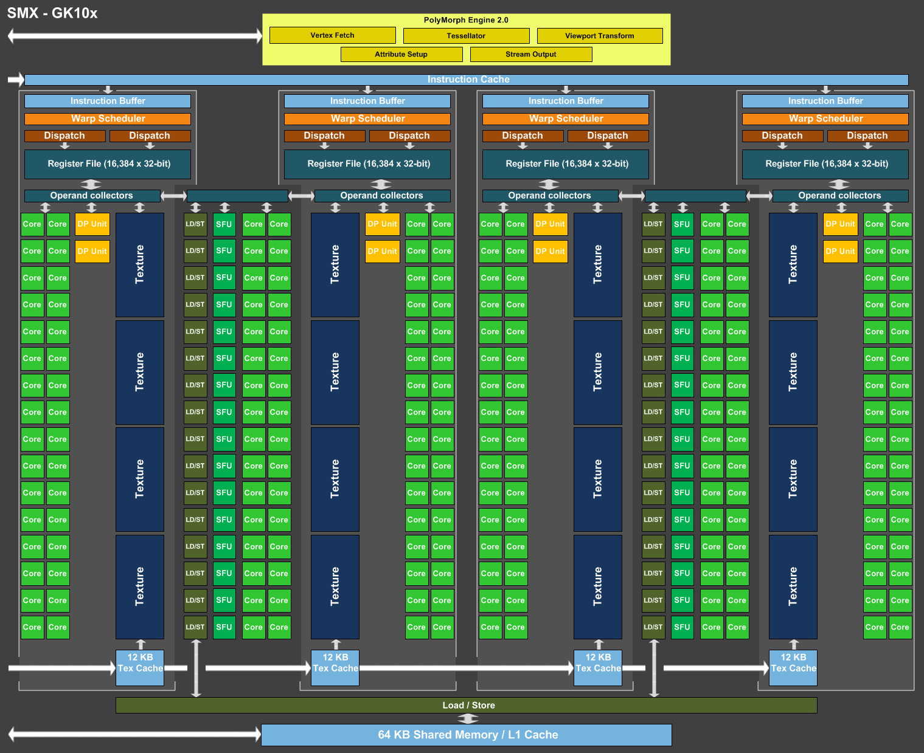
Reference: https://forums.developer.nvidia.com/t/gpu-architecture-and-warp-scheduling/58010

4.2 Data flow in the GPU pipeline
The GPU pipeline controls how data moves and transforms throughout the process. From the moment data enters the GPU, it passes through a structured series designed for parallel computation and efficiency (Owens et al., 2008). The data flow involves several key stages:
- Data input: data that is sent to the GPU to perform tasks.
- Data transfer: the data is transferred to the GPU’s memory via high-speed buses (Hennessy & Patterson, 2017).
- Parallel Processing: once data enters the GPU, it is divided into many parallel threads and processed by millions of cores concurrently, following the SIMT model (Nickolls et al., 2008).
- Result output: after the operation is complete, the data is transferred either back into the GPU’s memory, to the CPU for further processing, or to display (Hwu, 2016).
An efficient pipeline ensures that there is no bottleneck between these processes, allowing for high throughput in data-intensive tasks (Hennessy & Patterson, 2017).

4.2.1 Data transfer
An early or late stage in the GPU pipeline is data transfer, which refers to moving data from CPU memory to GPU memory (Nickolls et al., 2008). There are two types of data transfer:
- Host to Device: Moving data from CPU memory to GPU memory before the completion of the operation (Owens et al., 2008).
- Device to Host: Moving data from GPU memory to CPU memory after completion of the operation (Hennessy & Patterson, 2017).
These data transfers use the PCIe (Peripheral Component Interconnect Express) bus. However, the speed of this method is comparatively slower than the speed of GPU internal operations, so minimizing unnecessary transfers is important to maintain high speed (Hwu, 2016).
Modern technologies such as Unified Memory allow the CPU and GPU to use shared memory, reducing the need for manual transfers (Jouppi et al., 2017). On the other hand, asynchronous data transfer techniques enable data to transfer while the GPU continues processing other operations, optimizing the pipeline further (NVIDIA Corporation, 2023).
NVIDIA’s NVLink and upcoming Compute Express Link standards promise to make data transfer faster and more efficient (NVIDIA Corporation, 2022). These technologies aim to enhance the overall efficiency of data movement between the CPU and GPU, which is critical for high-performance workloads in AI and other fields (Nickolls & Dally, 2010).

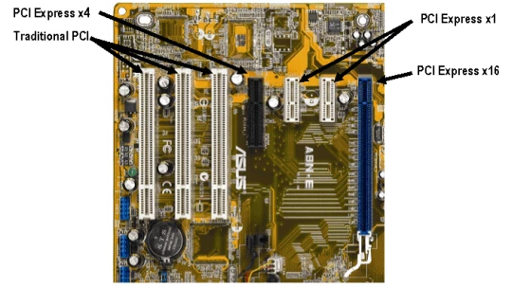
Reference: https://www.ni.com/en/shop/introduction-to-pci-express.html

4.2.2 Instruction Dispatch
Instruction Dispatch is the process where the GPU sends instructions to cores so they can start working. In simple terms, dispatching means assigning work. It’s the step where the GPU controller takes an instruction and hands it out to the right processing units (cores) (Owens et al., 2008).
In a GPU, dispatch works in a parallel and massive scale way:
- Groups of threads are managed together.
- The warp scheduler picks a warp that is in a ready state (Nickolls et al., 2008).
- The scheduler dispatches the next instruction for the warp that is available to execution units (Nickolls & Dally, 2010).
- The execution units perform the instruction on the assigned dataset (Hennessy & Patterson, 2017).
This dispatching happens every clock cycle, trying to keep all the units busy in every possible way. If a warp is stalled, the scheduler quickly picks another warp in a ready state and dispatches its instruction instead, as mentioned earlier (Hwu, 2016).
Instruction dispatch keeps thousands of threads working at the same time. It hides memory latency and ensures the GPU cores are always busy, achieving high throughput (Jouppi et al., 2017).

4.2.3 Execution by cores
Once an instruction is dispatched by the GPU scheduler, it needs to be executed by the GPU’s cores. GPU cores are also known as execution units. Each GPU core is responsible for performing simple instructions like addition, subtraction, multiplication, comparison, or logical operations on the data assigned to it (Nickolls et al., 2008). Since GPUs have millions of cores, they can execute many instructions at the same time, providing massive parallel power (Owens et al., 2008).
How it flows:
- The warp scheduler dispatches an instruction to a warp (Nickolls & Dally, 2010).
- Each thread in a warp has a piece of data to process (Nickolls et al., 2008).
- Each core takes the instruction and the corresponding data to process (Hennessy & Patterson, 2017).
- The core executes the process, such as calculating the pixel color or multiplying numbers (Hwu, 2016).
Each thread in a warp performs the same operation, but the data might be different. Specialized cores may exist in the GPU, such as FP32 cores for single-precision math or Tensor cores for deep learning (Jouppi et al., 2017). Execution happens synchronously in a warp, but different warps may be at different stages of execution (Nickolls & Dally, 2010).

4.2.4 Memory access and caching
In GPUs, memory access refers to how threads read and write from memory during ongoing processes. Because there are millions of threads running in parallel, managing memory access is critical to maintaining the workflow of GPU cores (Owens et al., 2008).
GPUs have several layers of memory:
- Global Memory (VRAM)
  - Large and shared by all threads.
  - Slow compared to on-chip memory.
  - Used for large sets of data (Hennessy & Patterson, 2017).
- Shared Memory (On-chip)
  - Shared by cores within the same block.
  - Much faster than global memory (Nickolls et al., 2008).
- Registers
  - Ultra-fast and small personal memory for all the cores.
  - Used for temporary storage during the ongoing process (Nickolls & Dally, 2010).
- Constant Memory
  - Read-only memory used to broadcast the same value to many threads (Hwu, 2016).
- Texture/Surface Memory
  - Specialized read-only memory for 2D/3D spatial data (Hennessy & Patterson, 2017).
Caching in GPUs
Just like CPUs, GPUs use caches to speed up memory access:
- When a thread requests data, it checks in cache memory. If the required data is found, it is quickly retrieved without accessing slower memory. If not, the GPU must fetch it from slower memory (Owens et al., 2008).
- Typically, GPUs have L1 cache, which is close to each SM and fast, and L2 cache, which is larger in size and slower than L1 but faster than global memory (Jouppi et al., 2017).

4.2.5 Output
After a GPU finish completing tasks, whether it is rendering graphics or training a neural network, the result must be transferred back to where it is needed next. This final step in the pipeline involves two important actions: output and data transfer (Hennessy & Patterson, 2017).
Output:
In graphics rendering, the output may be displayed on the screen. In compute applications, output could be prediction results, processed datasets, or simulation values. This output is temporarily stored in the GPU's VRAM until it is either used for another operation inside the GPU or prepared to be sent out of the GPU to the CPU or displayed (Nickolls et al., 2008).
Data Transfer:
Once the output is ready, data transfer moves it from the GPU to the CPU or another device. This transfer typically happens using PCIe buses (Owens et al., 2008).
There are two types of data transfer:
- Device to Host Transfer: In this case, the final output is sent from GPU memory to CPU memory.
- Device to Device Transfer: In some advanced systems, the GPU can transfer data directly to another GPU without the involvement of the CPU (Jouppi et al., 2017).
PCIe bus transfers are slower compared to internal GPU operations. As a result, engineers aim to minimize the amount of data that needs to be transferred or overlap data transfer with computation using asynchronous operations (Nickolls & Dally, 2010).

4.3 GPU Optimization Technique

4.3.1 Memory Coalescing
One crucial GPU optimization technique is memory coalescing, which improves the efficiency of memory access by reducing memory latency (Hennessy & Patterson, 2017). In a GPU, when threads within a warp try to access memory addresses consecutively, the hardware combines these memory accesses into a single memory transaction. This process is called coalescing. This minimizes the number of transactions, reduces memory latency, and increases overall throughput (Owens et al., 2008). In contrast, if a thread tries to access irregular memory addresses, multiple separate memory fetches are needed, leading to inefficient use of bandwidth and slower execution (Nickolls & Dally, 2010). Data structures must be organized so that threads access neighbouring memory locations, and memory should be aligned properly to achieve optimal coalescing. Memory coalescing is important to maximize the performance of GPU programs, especially in applications that have large datasets, such as deep learning and image processing (Jouppi et al., 2017).

4.3.2 Instruction level parallelism
Instruction Level Parallelism (ILP) is a key optimization technique in GPU computing to enhance performance by allowing multiple instructions to be executed within a single processing unit (Hennessy & Patterson, 2017). In GPUs, ILP is achieved when a single thread issues multiple independent instructions that can be processed simultaneously by different execution units (Owens et al., 2008). By overlapping arithmetic, memory, and control operations, ILP helps maximize the usage of GPU resources and minimize cycles (Nickolls et al., 2008). The use of ILP reduces the need for frequent context switching between warps and enables higher throughput for each thread (Jouppi et al., 2017). To use ILP effectively, code must be structured to minimize the data dependencies between instructions, ensuring that the GPU can schedule and execute multiple operations without waiting for previous operations (Hennessy & Patterson, 2017).

4.3.3 Latency hiding
Latency hiding is a performance technique used in GPUs to overcome delays caused by slow memory or instruction execution (Nickolls & Dally, 2010). Instead of waiting for memory fetches or long latency operations to complete, GPUs hide these delays by switching between available warps in a ready state and executing instructions from other ready warps (Owens et al., 2008). This ensures that cores remain busy and productive, even when some threads are stalled (Jouppi et al., 2017). GPUs focus on exposing large thread-level parallelism so that there is always a thread in a ready state to execute (Hennessy & Patterson, 2017). Latency hiding allows GPUs to maintain a high amount of work and efficiency, particularly in processes with frequent memory access or unpredictable data dependencies (Hwu, 2011).

4.4 Real world example
Cryptocurrency mining is a perfect example that integrates all the concepts regarding GPU performance and optimization (NVIDIA, 2020). In mining, the GPU performs a large amount of parallel computation to solve puzzles. The aim is to maximize transactions per second, which directly influences how much currency is mined (Mayer et al., 2019).
- Data Flow in the GPU Pipeline
Each mining task involves a complex cryptographic calculation, where the cryptographic block data enters the GPU as input. It is then processed through multiple stages in the pipeline, and the output is produced (Owens et al., 2008). Data transfer between CPU and GPU is used to fetch and store intermediate computational results (Jouppi et al., 2017).
- Single Instruction, Multiple Data
Mining algorithms, like SHA-256 used in Bitcoin mining, can be efficiently parallelized. Multiple mining threads can execute the same instruction on different sets of data. This is where SIMD plays a role, with a single instruction applied to many independent data points, optimizing performance and increasing throughput (Hennessy & Patterson, 2017).
- Massive Parallel Architecture
GPUs used for mining have millions of small processing cores. These cores work in parallel to solve cryptographic puzzles, allowing for massive parallelism. The parallel nature of GPUs makes them more efficient than CPUs for this operation (Nickolls & Dally, 2010).
- Memory Coalescing
In mining, especially when dealing with large datasets of cryptographic operations, memory access efficiency is critical. If multiple threads access the same memory locations consecutively, memory coalescing ensures that these memory accesses are grouped into a single transaction, reducing the overhead of many small memory accesses and increasing throughput (Feng et al., 2016).
- Instruction Level Parallelism (ILP)
Mining algorithms often involve multiple steps, and these operations can be overlapped using ILP. While some threads wait for data to be fetched from memory, others continue processing other parts of the algorithm, reducing time and improving efficiency (Hwu, 2011).
- Latency Hiding
During mining, memory access latency can be significant when dealing with large datasets. To hide this latency, GPUs utilize warp scheduling. While one group of threads waits for memory fetches, other threads within the warp are scheduled to run. This keeps the GPU core busy, hiding latency and maintaining throughput (Owens et al., 2008).
- Throughput
The ultimate goal of mining GPUs is to generate the maximum possible outcome or performance. The more cryptographic calculations the GPU can process per second, the more likely it is to solve the mining problem and earn cryptocurrency. Optimizing for high throughput in a mining scenario means ensuring that latency hiding, memory coalescing, and ILP are fully utilized, and the GPU is kept as busy as possible with minimal idle time (Jouppi et al., 2017).

5. Emerging application of GPUs

5.1 GPUs in AI and ML
In recent years, Artificial Intelligence and Machine Learning have become emerging fields that demand high-performance GPUs (Schmidhuber, 2015). GPUs, originally created for rendering real-time graphics, have proven to be highly effective in AI and ML due to their massive parallel architecture, which is well-suited to process large matrices and vector operations in deep learning algorithms (Krizhevsky et al., 2012). In operations like training deep neural networks, GPUs use their millions of cores to perform significant computations, reducing time compared to CPUs (Raina et al., 2009). Additionally, a technique known as Tensor Cores, introduced by NVIDIA, is specifically designed to optimize matrix operations, which are crucial for AI applications (NVIDIA, 2017). In ML operations such as image recognition, natural language processing, and many more, GPUs enable rapid data processing and complex model architectures, making real-time AI feasible in industries such as healthcare, finance, and robotics (LeCun et al., 2015; Silver et al., 2016).

5.2 Scientific computing
Scientific computing involves tasks like simulation, numeric modeling, data analysis, etc. These tasks have recently adopted GPU acceleration to achieve breakthroughs in both performance and scalability (Dongarra et al., 2014). Fields like quantum mechanics, bioinformatics, and others typically involve complex mathematical equations over large datasets, often requiring matrix operations and iterative algorithms (Asaro et al., 2013). GPUs, with their massive parallel structure, are ideal for solving these problems, allowing for thousands of operations to be performed simultaneously (Nickolls et al., 2008). High precision computing in GPUs, especially with support for double-precision floating-point operations, has made them essential for complex problem solving (Owens et al., 2008). Modern frameworks like CUDA and OpenCL provide access to tailor applications specific to GPU architectures, achieving significant speedups, with improvements of up to 100x compared to standard CPUs (Kirk & Hwu, 2016). As a result, GPUs have become a significant technology in supercomputers and research labs worldwide, enabling operations that were previously not feasible (Saylor et al., 2019).

5.3 Gaming and real time graphics
Gaming and real-time graphics have been the most dominant fields in the history of GPUs. In fact, GPUs were initially created for gaming and graphics rendering (Akeley, 2001). Modern GPUs are designed to handle high-level computation for rendering complex, real-time graphics with high fidelity at interactive frame rates (Lindholm et al., 2008). Gaming techniques like rasterization, ray tracing, and shading are heavily parallelizable, allowing GPUs to process millions of pixels simultaneously (Möller & Haines, 2002). Recent techniques, such as ray tracing, are supported by specialized ray tracing cores and tensor cores for AI-enhanced graphics, which have transformed gaming visuals to near-photorealistic levels (NVIDIA, 2018). GPUs also maintain low latency for next-level experiences in areas like Virtual Reality (VR) and Augmented Reality (AR) (McNamara & Birch, 2017). As a result, GPU performance directly defines the capability of gaming consoles and high-end PCs (Deering, 1995). GPUs are also used in cloud gaming platforms where graphics are streamed in real-time from powerful GPU-backed servers (NVIDIA, 2020).

5.4 Blockchain and cryptocurrency
The emerging technology in the field of GPUs also involves blockchain and cryptocurrency mining, particularly due to its high-level ability to handle a massive number of parallel hash computations (NVIDIA, 2018). Cryptography algorithms such as SHA-256 or ETHASH require solving complex mathematical puzzles that are inherently parallelized, making GPUs more effective compared to normal CPUs for mining operations (Xie et al., 2017). This massive parallel architecture of GPUs helps miners solve millions of hash calculations, increasing the probability of solving blocks and earning rewards (Poon & Dryja, 2018). Furthermore, GPUs offer the flexibility to adapt to different hash-solving algorithms, opposed to Application-Specific Integrated Circuits (ASICs), which are limited to specific tasks (Pereira et al., 2019). Beyond mining, GPUs are also widely used in blockchain-based applications and smart contracts that require fast computations in data validation (Croman et al., 2016). As blockchain systems use high-level computation mechanics like Proof-of-Work, GPUs remain crucial for both security and operational scalability (Narayanan et al., 2016).

6. Future threads

6.1 Automatic vehicles and robotics
The future of autonomous vehicles and robotics heavily depends on the evolution of GPUs, as they need to process large amounts of sensor data and make decisions by evaluating that data (Schwarting et al., 2018). In autonomous vehicles, GPUs are used for tasks such as path planning, LiDAR data interpretation, and mapping (Rosenblatt et al., 2020). Real-time object detection, classification, and environment mapping heavily rely on deep learning models that demand high throughputs and low latency, which are core strengths of modern GPUs (Li et al., 2019). In this environment, GPUs with AI and Tensor chips offer significant advancements (NVIDIA, 2020). Similarly, in robotics, GPUs are used for real-time motion planning, multi-agent coordination, and adaptive control systems, which are essential for handling unpredictable movements (Sutton & Barto, 2018). NVIDIA’s DRIVE platform is focusing on GPU-based architectures with an emphasis on AI acceleration, functional safety, and redundancy, which are essential for ensuring operational reliability (NVIDIA, 2020). As both fields advance, GPUs are expected to evolve with improved AI-specific hardware accelerators and enhanced edge computing capabilities to meet the growing demands of autonomous mobility and next-generation robotics (Yin et al., 2021).

6.2 Edge computation and cloud GPUs
As the demand for real-time responsiveness and massive computational power in applications increases, the integration of GPUs in edge computing and cloud environments is becoming critical for future trends (Shi et al., 2016). Edge computing refers to processing data near the source rather than relying entirely on distant cloud servers (Shi et al., 2016). Deploying GPUs at the edge enables low latency with AI interfaces, high-resolution video analytics, and responsive autonomous systems, while also reducing bandwidth usage and cloud dependency (NVIDIA, 2020). Devices like NVIDIA’s Jetson series exemplify this trend by offering GPU-powered AI at the edge (NVIDIA, 2020). Similarly, cloud GPUs are available through services such as Amazon EC2 P4, Google Cloud TPUs, and Microsoft Azure NC-series, which offer virtually unlimited scaling for AI training, scientific computing, and data analytics (Amazon Web Services, 2020; Google, 2020; Microsoft, 2020). By leveraging multi-GPU clusters and distributed deep learning frameworks, cloud service providers enable research that was once only possible on expensive local supercomputers (Chen et al., 2020). Future developments in this field are expected to focus on optimizing GPUs to improve energy efficiency and meet the diverse requirements of fields such as healthcare and autonomous mobility (Huang et al., 2021).

6.3 Quantum and Optical computing
While current GPUs dominate parallel computation for digital workloads, the future holds promise with emerging fields such as quantum computing and optical computing (Arute et al., 2019). Quantum computing has the potential to solve problems in optimization, cryptography, and material science that are not feasible with even the most advanced GPU clusters (Harrow et al., 2009). Engineers are working on hybrid architectures where GPUs manage classical operations, while quantum processors handle specific quantum workloads (Chuang & Nielsen, 2000). Similarly, optical computing uses photons instead of electrons for computing, offering the ability to transfer large amounts of data with lower energy consumption (Bimbard et al., 2020). GPUs powered by optical accelerators could complement or even partially replace traditional electronic GPUs for tasks that require ultra-fast computing and fast neural network inference (Lightmatter, 2020). Companies like NVIDIA, IBM, and startups such as Lightmatter are exploring the potential of photonic chips for future GPU designs (NVIDIA, 2020; IBM, 2020). While fully operational photonic or optical chips are still in the research phase, their integration promises a major shift in fields like AI model training, scientific simulations, and complex decision-making (Lodahl et al., 2020).

7. Challenges and sustainability

7.1 Energy consumption concerns
One of the challenges GPU technologies face today is substantial energy consumption, especially as GPUs become more powerful and are widely deployed across industries (Jouppi et al., 2017). GPUs designed for operations such as deep learning, real-time rendering, and scientific simulations can consume up to 100 watts individually, and in data centers, GPU clusters can consume megawatts of power (Brown et al., 2020). This large energy consumption raises environmental concerns, particularly related to carbon emissions. Studies have shown that the carbon emissions involved in training a single large AI model can be equivalent to the entire lifetime emissions of five cars (Strubell et al., 2019). The challenges are further intensified by the growing demands of cloud-based GPU and edge deployments. In response, engineers are working on more energy-efficient architectures, such as dynamic voltage and frequency scaling (DVFS), low-power tensor cores, and memory compression techniques (Amad et al., 2021). Additionally, GPUs powered by optical and photonic processing are being explored as a way to reduce electrical load (Bimbard et al., 2020). Balancing performance with environmental responsibility will be crucial as GPUs continue to advance in fields such as AI, scientific computing, and autonomous technologies (Duan et al., 2021).

7.2 Sustainability of large-scale GPUs
The sustainability of large-scale GPUs, particularly in data centers and AI supercomputing infrastructure, is becoming a critical concern as the demand for these resources increases (Amad et al., 2021). Modern GPU clusters, which process vast datasets in fields such as deep learning, climate modelling, and bioinformatics, also consume significant amounts of electricity and contribute to carbon emissions (Strubell et al., 2019). Research from the University of Massachusetts, Amherst, indicates that training advanced AI models can emit as much carbon as several years of typical human activities (Schwartz et al., 2020). Furthermore, the manufacturing of GPUs involves the use of rare earth elements and complex fabrication processes, which also have significant environmental impacts (Lin et al., 2020). To address these concerns, companies like NVIDIA and AMD are heavily investing in energy-efficient GPU architectures, such as NVIDIA’s Hopper architecture and AMD’s CDNA architecture, which focus on high performance with minimal energy consumption (Amad et al., 2021). Additionally, the adoption of renewable energy sources to power GPU data centers, innovations in liquid cooling systems, and the development of recyclable materials for GPU components are leading steps to mitigate the environmental footprint (Liu et al., 2021). Ensuring the long-term sustainability of large-scale GPU use will require an approach that combines hardware innovation, smarter algorithms to minimize unnecessary computation, and a focus on green energy initiatives (Duan et al., 2021).

7.3 Green computing initiatives
In response to growing environmental concerns, green computing initiatives have emerged as an important framework for promoting the energy efficiency and sustainability of GPUs and computational hardware (Jin et al., 2020). These initiatives aim to minimize the environmental impact of technology through a combination of hardware innovation, software optimization, and energy sourcing strategies (Soni et al., 2021). Leading companies such as NVIDIA and AMD have committed to improving GPU designs that offer better performance while consuming less energy, incorporating eco-friendly cooling systems, and using sustainable fabrication processes (Liu et al., 2021). On the software side, green computing promotes the development of efficient algorithms, such as pruning redundant neural network layers or employing quantization techniques, which lower computational requirements without sacrificing accuracy (Zhou et al., 2020). Large-scale data centers utilizing GPU clusters are increasingly powered by renewable energy sources, such as solar, wind, and hydroelectric power, to reduce carbon emissions (Zhang et al., 2020). Industry-wide certifications, such as Energy Star and LEED, also encourage sustainable design and operational practices (Gartner, 2021). Overall, green computing initiatives inspire GPU-driven industries to prioritize environmental responsibility while striving for operational sustainability (Soni et al., 2021).

Deepseek v/s NVIDIA
As GPU technologies evolve and focus more on specialized chipsets and high-efficiency designs, new tech startups like Deepseek are challenging established companies like NVIDIA. NVIDIA has long been a leading company in the field of GPUs, with its extensive ecosystems and architectures like Ampere, Hopper, and Ada Lovelace, as well as AI-specific chips such as Tensor Cores, ray tracing units, and deep learning accelerators (NVIDIA Corporation, 2022; Jouppi et al., 2017). Its priority software stacks, such as CUDA, TensorRT, and Omniverse, provide platforms for industries ranging from gaming to AI supercomputing (NVIDIA Corporation, 2022). In contrast, Deepseek has focused its efforts on developing AI-centric hardware, designing GPUs with massive parallel architecture, low-latency inference, and energy-efficient tensor operations. Deepseek’s architecture focuses mainly on memory bandwidth optimization and custom dataflow architecture, making them highly effective for training and deploying large-scale machine learning models (DeepSeek Technology, 2024).
The market impact of Deepseek’s announcement was immediate: NVIDIA’s stock prices experienced a notable dip, driven by concerns from investors about potential competition in the AI acceleration and data center markets—two of NVIDIA’s fastest-growing and most profitable segments (Financial Times, 2024). Experts noted that Deepseek’s approach to building domain-specific GPUs could erode NVIDIA’s dominance in certain ways, especially in AI-focused fields that prioritize speed, efficiency, and scalability over general-purpose capabilities (Hennessy & Patterson, 2017). While NVIDIA still maintains a massive technological and ecosystem advantage, the arrival of Deepseek points to the growing demand for hyper-specialized GPUs, potentially leading the market where new players can thrive. Overall, while NVIDIA remains dominant, Deepseek’s innovations highlight the industry’s shift toward specialized chips and the increasing emphasis on efficiency in next-generation designs (Hennessy & Patterson, 2017; NVIDIA Corporation, 2022).

Conclusion

9.1 Summary of key findings
This research has explored the technological evolution, data processing mechanisms, emerging technologies, and sustainability challenges surrounding Graphics Processing Units (GPUs). Initially designed to render graphics, GPUs are now used to perform massive parallel operations on large amounts of data across fields such as Artificial Intelligence, scientific computations, deep learning, blockchain, cryptocurrency mining, and real-time graphics (Hennessy & Patterson, 2017; NVIDIA Corporation, 2022). The study highlighted the role of architectures like Single Instruction, Multiple Data (SIMD) models, massively parallel cores, instruction dispatch systems, and memory hierarchy, which enable the high throughput and low latency required by modern applications (Nickolls et al., 2008; Owens et al., 2008). Critical optimizing techniques such as memory coalescing, instruction-level parallelism, and latency hiding were explored, as these techniques maximize GPU efficiency (Hwu, 2011; Nickolls & Dally, 2010). The study also revealed the importance of green computing initiatives in mitigating the environmental impacts of large-scale GPU deployment, highlighting the future trends of energy-efficient GPUs (Murugesan, 2008; Strubell et al., 2019). Moreover, a comprehensive analysis of Deepseek vs. NVIDIA was illustrated, providing insight into the shifting dynamics of the GPU industry, where emerging players introduce specialized architectures that could be the next big development in the field (Financial Times, 2024; DeepSeek Technology, 2024). Overall, GPUs have become indispensable for modern computation, but their continued development must balance technological advancements and environmental challenges (Hennessy & Patterson, 2017).

9.2 Future impacts of GPU
Looking further, the impacts of GPUs on technology and society are predicted to grow even more. As the demand for fast computational power increases in fields such as artificial intelligence, quantum computing, autonomous systems, and healthcare, GPUs will continue to drive innovation (Hennessy & Patterson, 2017; NVIDIA Corporation, 2022). Future GPUs are expected to focus more on fields like heterogeneous computing, optical interconnects, and quantum computing, pushing the limits of speed, parallelism, and energy efficiency (Arute et al., 2019; Lightmatter, 2021). Furthermore, the democratization of AI tools backed by GPUs could be transformative across industries, ranging from healthcare to climate modeling and smart city development (Goodfellow et al., 2016; Thrun et al., 2005). However, these benefits must be balanced against growing concerns like energy consumption, electronic waste, and carbon emissions (Strubell et al., 2019; Murugesan, 2008). The integration of GPU technologies with green computing will be essential for ensuring that the future impacts of GPUs on both technological advancements and environmental challenges are sustainable (Patterson & Hennessy, 2017). Thus, future continuous research, responsible innovation, and interdisciplinary collaboration will be vital in shaping a future where GPUs progress without compromising environmental challenges (Hennessy & Patterson, 2017).

References

- Akenine-Möller, T., Haines, E., & Hoffman, N. (2018). Real-Time Rendering (4th ed.). CRC Press.
- Arute, F., Arya, K., Babbush, R., et al. (2019).
Quantum supremacy using a programmable superconducting processor. Nature, 574(7779), 505–510. https://doi.org/10.1038/s41586-019-1666-5
- Chen, C., Seff, A., Kornhauser, A., & Xiao, J. (2015). DeepDriving: Learning Affordance for Direct Perception in Autonomous Driving. Proceedings of the IEEE International Conference on Computer Vision (ICCV).
- DeepSeek Technology. (2024). DeepSeek AI Accelerator Overview.
- Financial Times. (2024, October). DeepSeek unveils AI GPU, shares of Nvidia slip. FT Tech Brief.
- Gencer, A. E., Basu, S., Eyal, I., Van Renesse, R., & Sirer, E. G. (2018). Decentralization in Bitcoin and Ethereum Networks. Financial Cryptography and Data Security.
- Goodfellow, I., Bengio, Y., & Courville, A. (2016). Deep Learning. MIT Press.
- Hennessy, J. L., & Patterson, D. A. (2017). Computer Architecture: A Quantitative Approach (6th ed.). Morgan Kaufmann.
- Hennessy, J. L., & Patterson, D. A. (2017). Computer Organization and Design: The Hardware/Software Interface (5th ed.). Morgan Kaufmann.
- Hwu, W. W. (2011). GPU Computing Gems: Emerald Edition. Morgan Kaufmann.
- Hwu, W. W. (2016). Programming Massively Parallel Processors: A Hands-on Approach (3rd ed.). Morgan Kaufmann.
- Jouppi, N. P., Young, C., Patil, N., et al. (2017). In-Datacenter Performance Analysis of a Tensor Processing Unit. Proceedings of the 44th Annual International Symposium on Computer Architecture (ISCA).
- Khronos Group. OpenCL Documentation.
https://www.khronos.org/opencl/
- Lightmatter. (2021). Photonics for Machine Learning [White Paper].
- Murugesan, S. (2008). Harnessing Green IT: Principles and Practices.
IEEE IT Professional, 10(1), 24–33. https://doi.org/10.1109/MITP.2008.10
- Narayanan, A., Bonneau, J., Felten, E., Miller, A., & Goldfeder, S. (2016). Bitcoin and Cryptocurrency Technologies: A Comprehensive Introduction. Princeton University Press.
- Nickolls, J., Buck, I., Garland, M., & Skadron, K. (2008). Scalable Parallel Programming with CUDA. Queue Journal.
- Nickolls, J., & Dally, W. J. (2010). The GPU Computing Era. IEEE Micro.
- Nielsen, M. A., & Chuang, I. L. (2010). Quantum Computation and Quantum Information. Cambridge University Press.
- NVIDIA Corporation. (2022). NVIDIA Hopper Architecture Whitepaper.
- NVIDIA Corporation. (2022). NVIDIA Jetson Platform Overview.
- NVIDIA Corporation. (2022). NVIDIA DRIVE AGX Developer Guide.
- NVIDIA Corporation. (2023). NVIDIA Environmental, Social, and Governance (ESG) Report.
- NVIDIA Corporation. CUDA Programming Guide.
https://docs.nvidia.com/deeplearning/performance/dl-performance-gpu-background/index.html
- NVIDIA Developer Blog.
https://developer.nvidia.com/blog/
- Owens, J. D., Houston, M., Luebke, D., Green, S., Stone, J. E., & Phillips, J. C. (2008). GPU Computing. Proceedings of the IEEE.
- Patterson, D. A., & Hennessy, J. L. (2017). Computer Architecture: A Quantitative Approach (6th ed.). Morgan Kaufmann.
- Pharr, M., Jakob, W., & Humphreys, G. (2016). Physically Based Rendering: From Theory to Implementation (3rd ed.). Morgan Kaufmann.
- Satyanarayanan, M. (2017). The Emergence of Edge Computing. Computer, IEEE.
- Strubell, E., Ganesh, A., & McCallum, A. (2019). Energy and Policy Considerations for Deep Learning in NLP. Proceedings of ACL 2019.
- Thrun, S., Burgard, W., & Fox, D. (2005). Probabilistic Robotics. MIT Press.
- Wyrwas, R. (2018). Graphics Processing Units: Trends and Evaluation for Space Applications. NASA NEPP.
https://nepp.nasa.gov/files/29564/NEPP-BOK-2018-Wyrwas-GPU-TN60884.pdf
- Wikipedia contributors. (n.d.). Graphics processing unit. Wikipedia.
https://en.wikipedia.org/wiki/Graphics_processing_unit

